(Approx. 708 words)

NUANCES IN ITUNES FOR WINDOWS
Managing your authorized computers, managing your credit card for iTunes purchases, and converting iTunes M4A files to other sound file formats
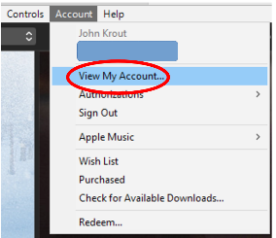Illustration 1
Part 2 of a 3-part series of articles
By John Krout, By John Krout, Presenter & Newsletter Contributor
Potomac Area Technology and Computer Society
https://www.patacs.org
jkrout.apcug.presenter (at) gmail.com

INTRODUCTION

As explained in Part 1 of this article series, when the COVID pandemic started, I felt that buying songs using iTunes had become an economical and safe alternative to buying used CDs at my local used CD retailer.

I ran into three problems, however. First, iTunes enforces a ceiling of five computers per account. The first problem was that I had "hit the wall," meaning I had authorized iTunes on five computers, four of which were dead and gone. The only one I still had in hand was my laptop. Therefore I could not authorize iTunes on my recently purchased desktop computer. Part 1 explained the iTunes technique for deauthorizing all computers using my iTunes account. First, I used my laptop, then reauthorized iTunes on my laptop and authorized iTunes on my desktop computer.

I also found out the credit card that I had given to iTunes many years ago had expired, and I was no longer using that credit card number. This Part 2 article explains how to set up a new credit card in iTunes. However, there is a nuance here that is not intuitive in iTunes, and you will read about that below.

In Part 3, you will learn how to configure iTunes so that you can convert any song purchased and downloaded using iTunes from the Apple M4A format to the widely used MP3 format so that you can copy the MP3 versions to any non-Apple player device, such as an Android phone or tablet.

UPDATING ITUNES CREDIT CARD INFO

Use these steps if, like me, you have exactly one credit card associated with your iTunes account, that card has expired, and you no longer use that card number.

STEP 1. Log into iTunes using your Apple ID and password.

STEP 2. In iTunes, pull down the Account menu and select View My Account. You can see that menu and menu choice in Illustration 1.
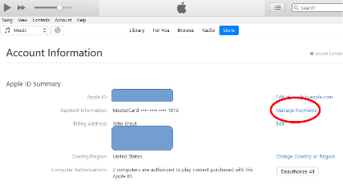Illustration 2
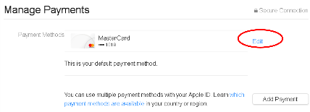Illustration 3
The Account Information page appears, as shown in illustration 2.

STEP 3. In the Account Information screen, click Manage Payments, which is circled in illustration 2.

The Manage Payments screen appears, as is shown in illustration 3.

STEP 4. In the Manage Payments screen, the sole credit card is summarized.

Notice that the Manage Payments screen also includes an Add Payment button, shown in the lower-left corner.

I clicked the Add Payment button, and iTunes refused to let me add a new card. There is no guidance on the screen specifying any prerequisite actions for adding a new card when the current card has expired. Clicking the Add Payment button causes an uninformative error message to appear.

Here's the nuance in the Manage Payments screen. When your current iTunes credit card is expired, before you can add another card using the Add Payment button, you must do one of two things:

* Update the expiration date of the current card, OR

* Delete the expired card.

In my case, since I no longer used that card number, I had to delete it.

To delete the expired card, click the Edit button, which is circled in illustration 3.

The Edit Payment information screen appears, as is shown in illustration 4.

To delete that unusable expired credit card, click on the Remove Payment Method button circled in the illustration. iTunes will again prompt you to enter your Apple ID and password.
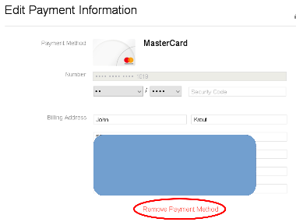Illustration 4

After that deletion was accomplished, the Manage Payments screen reappears. There, the Add Payment button enables you to add a new credit card.

This ends Part 2.

ABOUT THE AUTHOR: John Krout has been writing about personal computers and creative uses since the early 1980s. He frequently writes for PATACS Posts, the newsletter of the Potomac Area Technology and Computer Society, and occasionally provides demos on tech topics at PATACS meetings. He lives in Arlington, VA, with his son, many computers and cameras, and too many cats.

